**DAY 3 ASSIGNMENT**

LINUX ADMINIDTRATION BATCH 1

1. Create a blank file named "myfile".

ANSWER :

To create a blank file we have to use the comand “touch myfile”.

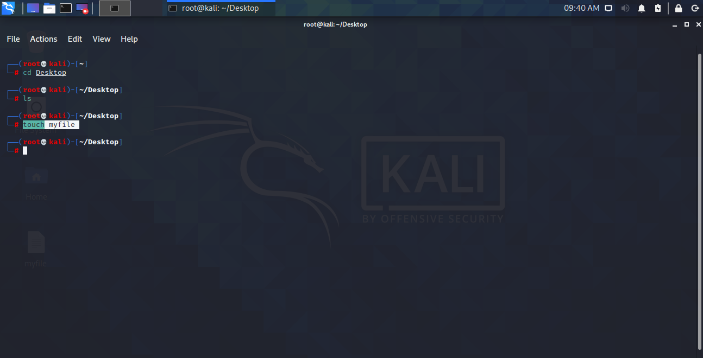

2. Open "myfile" in vi editor.

ANSWER :

To open myfile in vi editor, we have to use the command (assuming tht we are in the same directory of ‘myfile’) “vi myfile”.

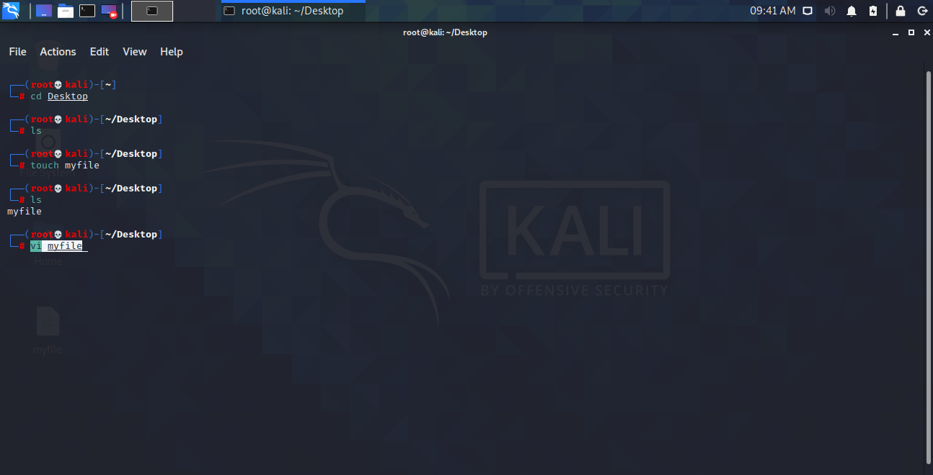

3. Write your name, address, email id, phone number and blood group in 5 different lines.

ANSWER :

To write data in ‘myfile’ we have to get into insert mode by typing ‘i’ and then write the data we want to in the file. After writing the data we have to get out of the insert mode. To get out of the insert mode we have to press ‘Esc’ key. And then we will press ‘:’ key to get into command mode and type “wq!” to write changes into file and quite.

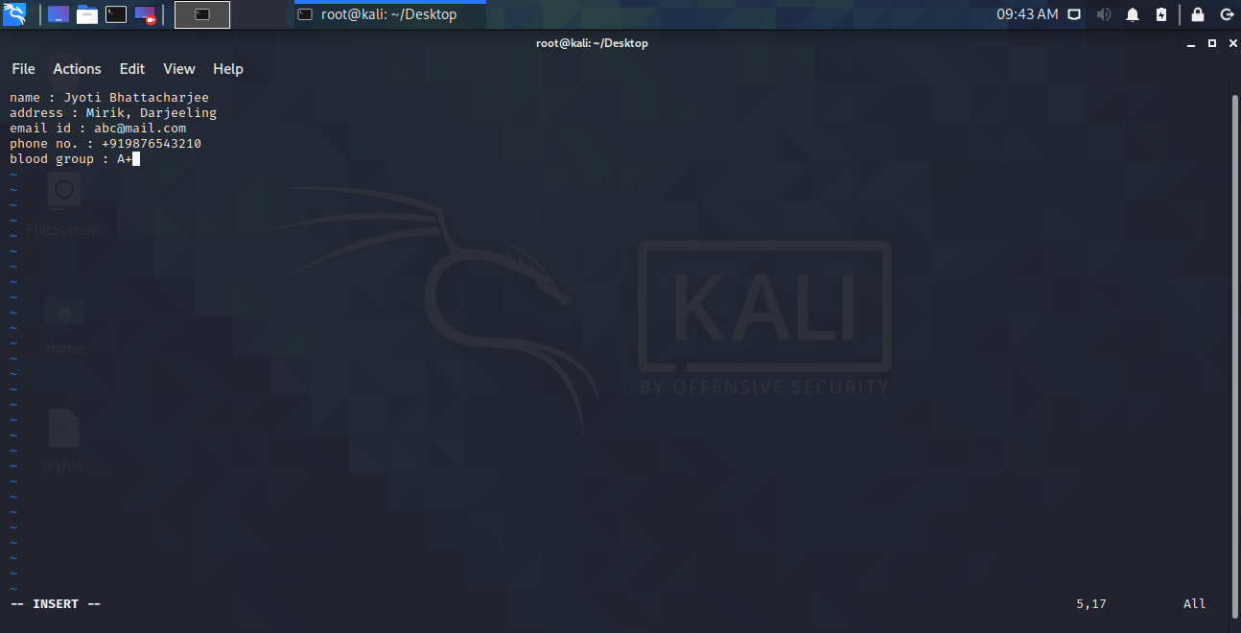

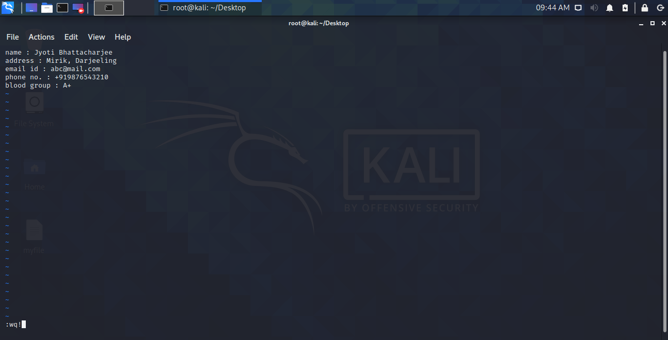

4. Build one single expression to see the line with your name and blood group in myfile.

ANSWER :

The single exprtession to see the line with name and blood group is : “cat myfile | grep -e name -e blood”(assuming that we are in the same directory of ‘myfile’).

